Speak Volumes Festival 2026: Guidance and Agreement for Artists / Stockists
Thank you for supporting our third festival by stocking your artwork in our Gallery (Arch 28) and/or gift shop in Arch 64! Please fill out the form below and read these terms of service to help us provide the best experience possible.
Whether you’re hoping to sell 1 item or 50: we need some information about your artwork to add it to our payment system.
Please send completed forms with your stocklist to speakvolumesfestival@gmail.com at your earliest convenience.
Please note that the deadline for stock lists is 8th May as we have to manually enter items into our system before the festival. If you need a deadline extension or other accommodations because of your disability, please get in touch, we’re happy to help.
We strongly recommend that your artworks / items for sale have a physical price label.

- Artist / Maker Name

- Primary contact
Name:
Phone:
Email:

- I’d like to sell art in…
Arch 28, Speak Volumes Gallery, items + artwork of all sizes: Yes / No
Arch 64, Mini Gallery / Festival Gift Shop (small items only): Yes / No
Note: You can sell at both venues if you’d like, IF we have the capacity.

- Can you confirm that you are able to drop off and pick up items on the following dates/times:
Drop Off:
Tuesday 26th May 12pm – 6pm Drop off at Arch 28 Yes / No
Wednesday 27th May 12pm – 6pm Drop off at Arch 64 Yes / No
Monday 1st June 12pm - 6pm Pick up from Arch 28 Yes / No
Monday 1st June 12pm - 6pm Pick up from Arch 64 Yes / No

If you need to arrange an alternative drop-off date, please get in touch ASAP, as we’re happy to be flexible. Contact our Festival Director, Freddie at: speakvolumesfestival@gmail.com

5. Your stock: In your own words, please describe what you are selling. (For example, clothing, original artwork, prints, hobby kits, soaps, snacks, stickers, greetings cards...)

6. Furniture / Display (please highlight / bold / delete as appropriate)
I will bring my own furniture/display rack, and set up on the drop-off day
I’m dropping off artwork / products only

7. Stock List: (please highlight / bold / delete as appropriate)
I have my own stock list, ready to send
I would like a template to copy/complete, via email or found the Speak Volumes Website
I need further assistance and would like to chat with somebody

Please send completed forms to speakvolumesfestival@gmail.com at your earliest convenience.

Terms and Conditions:
We strongly recommend that artwork / products are labelled with a price and name.
There is no listing fee to display your artwork at the Speak Volumes Gallery: Sold items ONLY will have a 10% commission. This means you will receive 90% of the sold price. The 10% kept by the festival is to cover our card reader and admin fees.
Because participation is FREE, in the event that you sell no artwork, you will not be charged. Commission is for sold items only.
PAYOUTS: All artists will receive their payouts as soon as possible. An email confirming your profits (a list of items sold) will be sent out for your approval - we will then request your bank details. Please do not give us your bank details before or during the festival, as we need to process them in accordance with GDPR.
Your artwork will be located indoors at our Arch venues on Croft Road, Worcester, WR1 3BD. Each venue will be open to the public from 10am to 8pm on the festival days, and securely locked overnight from 8:01pm to 9:59am.
The venues have step-free access but very limited parking options. Please be aware that the closest car park to Arch 28 is The Hive Car Park (aka Cattlemarket Car Park, Croft Road, Worcester) - within a minute walk. The closest parking to Arch 64, however, is street parking on Foregate Street or Sansome Walk.
By public transport: Crowngate Bus Station is a 3-minute walk away from The Arches. Worcester Foregate Street Station is a 30-second walk from Arch 64, or a 5-minute walk away from Arch 28.
Décor, tablecloths, and personal touches to display your products are encouraged! Please be mindful of the shared space, minimising potential to damage/stain others’ artwork, or injure festivalgoers in the gallery.
The Arches will be staffed throughout the day by the festival team, student volunteers, and security staff who can assist with lifting and stall set-up, and will administer payments during the festival.
Please consider that we are a non-profit organisation run for the benefit of local creatives and emerging artists. While we will work our utmost to ensure no damage or theft of artwork will occur, please understand the venue, festival, and volunteers/staff cannot be held liable for unmitigated damage or theft.

By filling out the form above, you have indicated that you agree to the arrangements specified in this document. You will be contacted with a confirmation of your marketplace booking.
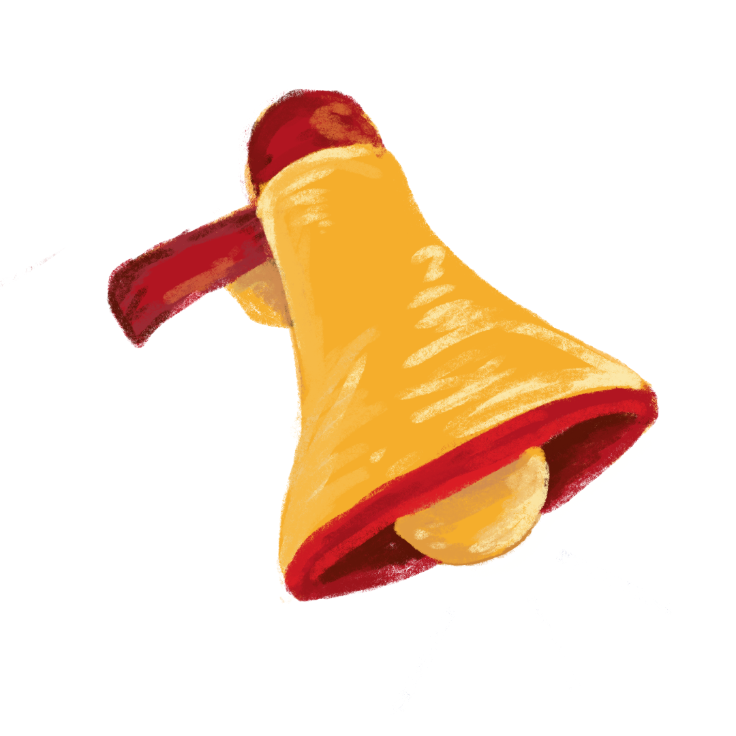
Good luck – many thanks - and enjoy! – Freddie 😊
Freddie Barker
Festival Director for SPEAK VOLUMES! Festival (29th, 30th, 31st May 2026)
Speak Volumes Festival CIC – Registered not-for-profit in England and Wales #15165674
Find SPEAK VOLUMES! Online: www.speakvolumesfestival.co.uk // www.instagram.com/speakvolumesfestival/

